Student Management System:

This is a demo java spring based project in which I am creating new students, and displaying all the students in a class.
Also I am using login process to login to the system and do some add and display activity.
Here I have used data structure List to add students to the records and displaying them from the stored database.
Along with that I am using inner class so that only one detail student_ID is there along with the inner class having other details like first name, last name, address and emailID as well. So I am splitting the details in two classes and accessing them using List data structure.
Main functionalities which is currently working are:
- Adding a student using jsp form
- Displaying all students in a class.
- Searching a particular student by using student ID, whether he is existing or not.
There are some improvements which can be done like deleting the students, searching using other fields like first name, last name, email ID, address. Also one major improvement can be like
- adding a new class field like course name,
- course ID in which student is enrolled.
- Also, searching using these fields also can be implemented as well.
- Adding login roles like student/admin to decide for limited access or full access. Student can view just his profile and update some fields like address and email ID. Admin can have full access rights to change student data.

Some screenshots of the demo project are attached here.

For login purpose I have used a dummy login name
name: admin
password: password
When the user login to this, the user can add new student, display all students and search a particular student from the database.
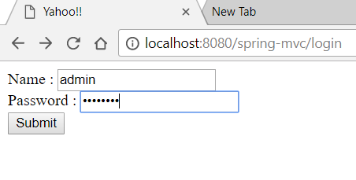
After login, the administrator gets three options as shown below:
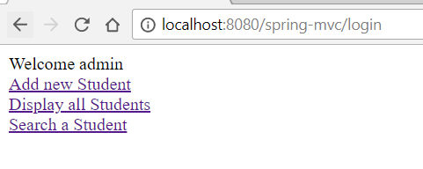
The first option is for adding a student to database. so the form opens up like this.
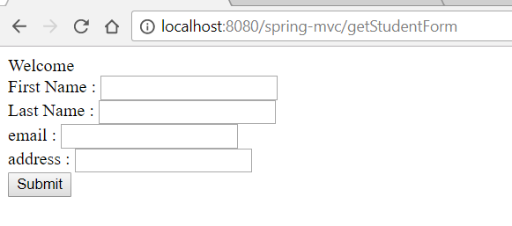

The second option returns all the results from the database and displays this on the jsp page as shown below.
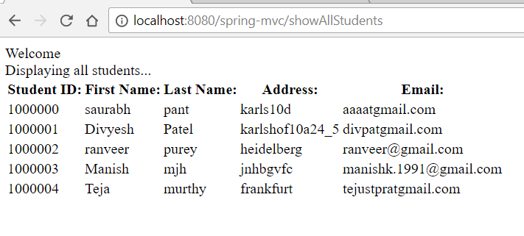

The third option is for searching a student based on many parameters. I have implemented it for property student_ID.
So I can enter student ID in this field as of now to get details of an individual student from the database and displaying on the page.
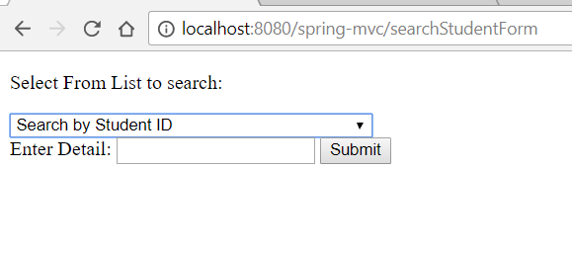
So I enter a student_ID to search for:
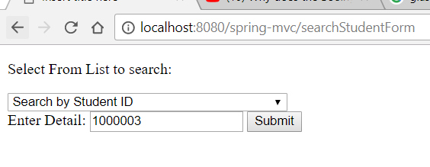

After this when we submit this, we get the results from database.

